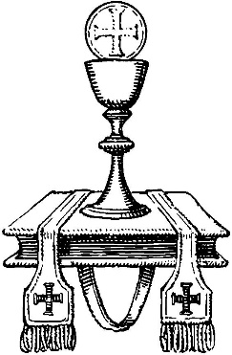

Weekday Altar Serving Guide

Before Mass:
- Please be at the chapel sacristy by 7:50am
- Vest in alb and cincture, and wait outside the sacristy for the priest

During Mass:
- Process in front of the priest to the front of the altar, and genuflect with him
- Sit in the chair to his left
- Bring the Roman Missal to the priest after he says “Let us pray”
- After the Prayer of the Faithful, bring the Roman Missal to the altar
- Bring to the altar the chalice, communion cup(s), and the paten
- Then, bring the water and wine cruets. Replace these on the credence table after the priest has finished with them.
- Then bring the water pitcher and lavabo bowl to wash the priest’s hands
- Kneel at your chair during the Eucharistic Prayer
- Altar servers are the last to receive Holy Communion
- After Communion, return the chalice and any other sacred vessels to the credence table
- Bring the Roman Missal back to your chair, and be ready to hold it again when the priest says “Let us pray”
- After the blessing, line up for the procession in front of the altar, and genuflect with the priest.
- Finally, process out, leading the priest to the sacristy

After Mass:
- Extinguish candles
- Bring cruets to the sacristy
- Neatly hang up the alb in the closet
- Promptly return to school

Most importantly, have a prayerful Mass serving at the Altar of the Lord.
Thank you for your service!

